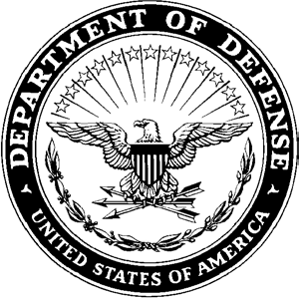**DEPARTMENT OF THE ARMY**

**HEADQUARTERS, AIRBORNE and RANGER TRAINING BRIGADE 10850 SCHNEIDER ROAD**

**FORT MOORE, GEORGIA 31905-5000**

ATSH-RB 16 January 2025

MEMORANDUM FOR Airborne and Ranger Training Brigade

SUBJECT: [INSERT UNIT] Exception to policy for team allocation at the 41st Annual LTG(R) David E. Grange Jr. Best Ranger Competition

1. The [INSERT UNIT] requests an exception to the policy which outlines the number of teams allocated to the [INSERT UNIT] for the 41st Annual Best Ranger Competition. [INSERT EXTERNAL UNIT] is not using [INSERT NUMBER OF TEAMS] and the Commander, [INSERT BDE/DIVISION COMMANDER’S TITLE AND NAME], has agreed to allocate [INSERT NUMBER OF TEAMS] to the [INSERT UNIT] for participation in the 41st Annual LTG(R) David E. Grange Jr. Best Ranger Competition.
2. The POC for this memorandum is the [INSERT DIV G3 OR CHIEF OF STAFF INFORMATION].

LOSING UNIT G3/COS GAINING UNIT G3/COS

RANK, BRANCH RANK, BRANCH

POSTION POSITION

APPROVED/DISAPPROVED PHIL KINIERY

BRIGADIER GENERAL, IN

COMANNDANT